**Data Warehousing**

**Scenario:**

You are a data engineer hired by an ecommerce company named SoftCart.com. The company retails download only items like E-Books, Movies, Songs etc. The company has international presence and customers from all over the world. The company would like to create a data warehouse so that it can create reports like

* total sales per year per country
* total sales per month per category
* total sales per quarter per country
* total sales per category per country

You will use your data warehousing skills to design and implement a data warehouse for the company.

**Objectives:**

In this assignment you will:

* Design a Data Warehouse using the pgAdmin ERD design tool.
* Create the schema in the Data Warehouse

**Tools / Software:**

* ERD Design Tool of pgAdmin
* PostgreSQL Database Server

**Exercise 1 - Design a Data Warehouse**

Task 1 - Design the dimension table softcartDimDate

Using the ERD design tool design the table softcartDimDate. The company is looking at a granularity of a day. Which means they would like to have the ability to generate the report on yearly, monthly, daily, and weekday basis.

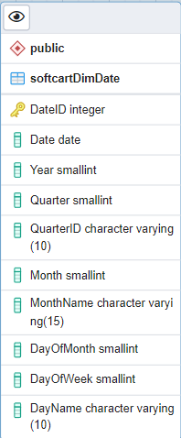

Task 2 - Design the dimension table softcartDimCategory

Task 3 - Design the dimension table softcartDimItem

Task 4 - Design the dimension table softcartDimCountry

Note: Task 2 to Task 4 Solution is below image

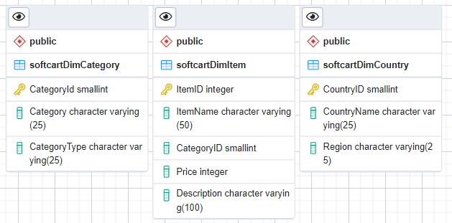

Task 5 - Design the fact table softcartFactSales

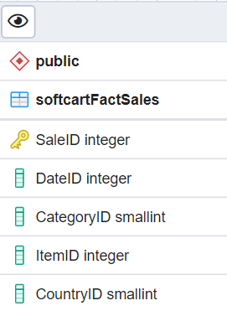

Task 6 - Design the relationships

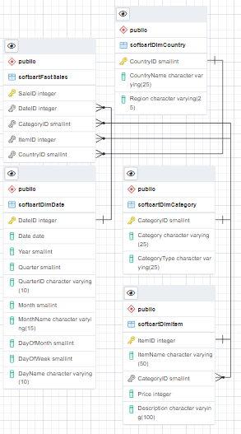

**Exercise 2 - Create the schema**

Task 7 - Create the schema.

Download the schema sql from ERD tool and create the schema in a database named staging

